**Mere Town Council**

**Clerks Report for Town Council meeting 3.3.2025**

**Agenda Items:**

***5d) Resources, timetable & information for Town & Parish Council elections***

All 2,118 Parish & Town Council seats are up for re-election on 1st May 2025 alongside the election for Wiltshire Councillors to the 98 Unitary Divisions.

Guidance for Candidates is available on The Electoral Commission website: <https://www.electoralcommission.org.uk/guidance-candidates-parish-council-elections-england/resources-candidates-parish-council-elections-england>

**Key election dates:**

| Task | Date |
| --- | --- |
| Publication of the Notice of Election | 11 March 2025 |
| Nominations open (nominations can be delivered between the hours of 10am and 4pm on working days) | 12 March 2025 - 10am |
| Nominations close | 2 April 2025 - 4pm |
| Deadline to register to vote | 11 April 2025 - midnight |
| Deadline to apply for or cancel a postal vote or change an existing postal or proxy vote. This is the deadline for receiving new postal vote applications, cancelling an existing postal vote, changing a postal vote arrangement, changing from a proxy vote to a postal vote and changes to existing proxy votes. | 14 April 2025 - 5pm |
| Deadline to apply for a new proxy vote | 23 April 2025 - 5pm |
| Deadline to apply for a Voter Authority Certificate | 23 April 2025 - 5pm |
| Deadline to appoint polling and counting agents | 24 April 2025 |
| Polling day | 1 May 2025 -7am to 10pm |
| Verification and counting of votes | 2 - 3 May 2025 |
| Deadline for the return of election expenses - Parish and Town elections | 29 May 2025 |
| Deadline for the return of election expenses - Wiltshire Council elections | 6 June 2025 |

***\*7b) Integrated planning for a sustainable future – correspondence from Mr. Nick Gosse (copied below):***

“Kindly distribute this to the Chair and all TC members, I'll leave it to George Jeans to share it with the County Council.

The conundrum of how to preserve the historic charm of a rural village or town whilst accommodating ever increasing demands for residential and commercial building is a very typical one in the United Kingdom, Mere is no exception. 'Historic Mere' , offering "quality of life in a rural idyll", is part of the promotional sales material that's used by developers to sell Mere's charm and attraction.

When we moved to Mere over four years ago, there were still intercontinental class articulated lorries accessing the Beaumont light industrial area from the A303 via Boar Street, Pettridge Lane, Edge Bridge and Clements Lane, there were also commercial quantities of mixed waste including plastics and composite materials being burned on the site.

The Mere bypass and the development of adjacent light industrial areas with good access to the new A303 dual carriageway was a landmark development for the town. It is clear however that this major project was not part of an integrated longer term strategic plan that addressed the inevitable re-designation of the old light industrial areas at the Woodlands and the Beaufort sites with consideration given to the significant increase in vehicular and pedestrian access via the naturally un-alterable constrictions posed by the main access via Boar Street, Pettridge Lane, Edge Bridge and Clements Lane. That is why I attached the drawing ref: jpg 8701 with the Local Plan Representation Form I submitted in November 2023 to WCC , see attached ref: jpg 8699. WCC Planning have confirmed to me that no such alternative route is under consideration.

It is now clear to me why I got the response given at a Town Council meeting I attended in 2022 and was told the situation as far as all vehicular access went was that  "it had ever been thus" and that there were no alternatives, after which I was also reminded that the Town Council did not have statutory rights.

Creeping caravan/mobile home site development on agricultural land down narrow country lanes on the Town's peripheral, again indicates that there is no long term integrated development plan in place for Mere. That the Beaumont site has been allowed to be vandalised is also symptomatic of a flawed system of basic control, both at County Council and County Police level.

I have stressed in communications with both the Town and County Councils that Mere's Government approved housing expansion for the Town is not, in itself, an issue. The main concern shared by the Mere residents I know or have spoken to, is that the improvement of the road/pavement infrastructure must be commensurate with the significant increase in vehicular and pedestrian traffic created by all new completed/planned housing development that depends on Boar Street, Pettridge Lane, Edge Bridge and Clements Lane as it's principal North/South access route.

Natural restrictions caused by the narrowness of Pettridge Lane, practically means no widening is possible, so the only viable control would be to design a traffic calming scheme. The two South to North prioritised sections in Pettridge Lane do nothing to slow speeding vehicles, some travelling at twice the speed limit. They also provoke driver aggression, due principally to the fact that both the prioritised single lane sections rely on the line of sight of drivers travelling from either direction and the reliance on their individual judgement of the speed of travel of a vehicle that is clearly already committed to proceeding, regardless of the prioritised rights.

These issues will now be significantly exacerbated as the Catholic Church and Beaumont sites are developed, it is also difficult to see how a re-application for planning on the former First School site can be justifiably refused, as it was in the 1990's, on account of access to and existing traffic volume on Pettridge Lane, over 30 years ago ?!

Given Central Government's policies on climate change/global warming, carbon emission reduction, use of renewable energy, I have great difficulty in understanding how the County Council feels they were justified in allowing the Woodlands development, now nearing completion, to proceed without insistence on the installation of any renewables,   that could have included solar PV on all roofs, a site wide ground source heat gathering system and a communal rainwater gathering system to contribute to all non-potable water requirements.

I recognise the difficulties for Town and Parish Councils to always be able to act in the best interests of it's residents. Also that we live in an age where the avoidance of responsibility, accountability and the use of gobbledeygook have become well practised art forms, particularly in Regional and Central Government.

 There is some leverage available before any further planning is approved, i.e for the Beaumont site. However without an integrated overall plan that considers the full  development of the light industrial areas adjacent to the A303, the possible addition of other retail outlets and the sum of the remainder of all other envisaged residential development, Mere will continue to have to rely on piecemeal planning, which has little regard for protecting the overall quality of life of it's residents.”

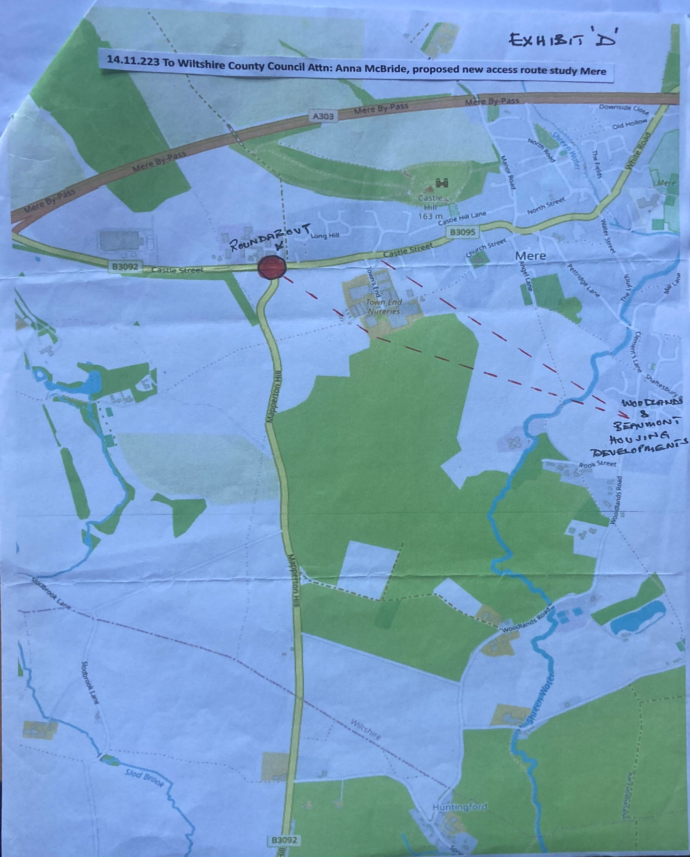

***\*8b) Response from National Highways to letter relating to flooding of A303 and ramps on bypass bridge at Manor Road***

I received a telephone call from Christopher Hilldrup of National Highways on 11.2.25 in response to my letter. He explained that they are well aware of the flooding problem which was largely due to the extraordinary weather conditions we have been getting. He said that he was aware that the attenuation pond was also spring fed which was not helping the situation. He said that their works team had been out recently and dug grips which was helping the problem and was more of a short-term measure and the drainage team were working on a longer-term solution – in fact, he was meeting with Andrew Murrison in the near future. I suggested that they invite Rodney Coward along too.

I also brought up the subject of the bridge ramps at Manor Road and he acknowledged that this was a National Highways problem and not a Wiltshire Council Highways problem. They were aware of it and were doing some monitoring at the present time to see what was happening and why and therefore work out how to address the problem.

***\*12a) Town & Parish Council Planning Forum 5th March (information in Clerks Report)***

The Head of Wiltshire Council’s Planning & Building Control writes:

“I am writing to inform you that we have changed the date of the Planning Town and Parish Council Forum because we are aware that there is another meeting taking place on the same date that many Town and Parish Councils will want to attend.

The new date will be **Wednesday 5th March – 6pm – 8pm**. We are trying this one as an online event following the feedback from last time. The topics will be:

* National Planning Policy update
* The Local Plan
* Planning Application Process and Planning Appeals – how we can work together
* Conservation and Design

If you would like to book onto this session, please email (redacted) and she will then send you the link to the Teams invitation.

If you have any specific questions relating to any of the above topics, please send them to (redacted), and we will do our best to ensure that these are covered during the event.

**Information Item**

In an email sent 4.2.25, Wiltshire Council’s Economic Development Service Manager writes:

**Wiltshire Council boosts the county’s tourism sector with support for Local Visitor Economy Partnership**

Wiltshire Council, working closely with Visit Wiltshire, has given a boost to the county’s thriving tourism industry by agreeing to support a Local Visitor Economy Partnership (LVEP).

LVEPs aim to provide strong local leadership and governance in tourism destinations around the country. They also look to foster strategic collaboration between local and national tourism agencies, bringing more visitors to the county and driving growth for communities and businesses.

The council has provided a letter of support to Visit England as part of the application process to secure LVEP status, which will help to unlock vital resources and funding to further develop Wiltshire’s thriving tourism sector.

Cllr Richard Clewer, Leader of Wiltshire Council and Cabinet Member for Economic Development, said: “We’re pleased to confirm our full support for the establishment of a Local Visitor Economy Partnership for Wiltshire.

“Tourism plays a vital role in our county, supporting local businesses, creating jobs, and preserving our rich cultural heritage.

“By forming this partnership with Visit Wiltshire, we will be able to unlock new opportunities for investment, promotion, and collaboration, ensuring Wiltshire remains a top destination for visitors from across the UK and beyond.

“This initiative aligns with our broader economic development strategy, reinforcing our commitment to sustainable tourism and community prosperity.

“We look forward to working closely with Visit England, Visit Britain, Visit Wiltshire and local partners through the LVEP to strengthen Wiltshire’s position as a leading visitor destination, creating jobs and further boosting the county’s economy.”

To find out more about the proposed LVEP and the decision to support it, people should go to: [Decision details - Democratic Services - Wiltshire Council](https://cms.wiltshire.gov.uk/ieDecisionDetails.aspx?ID=2098)